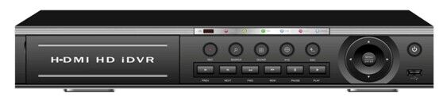
Digital video recorder 32ch
Model | 9432LM
System | Main processor | Industrial-grade embedded HiSilicon CPU
 | Operating system | embedded Linux
 | System resources | Simultaneously multi-channel real-time recording, playback, network operation, USB backup
Interface | Operator interface | support 16-bit true color graphical menu interface and mouse operation
 | Preview | 1/4 /9/16/24/32split screen
Video | Codec | H.264（High Profile）
 | Monitor quality | VGA；HDMI：HD
 | Playback quality | AHD-M
 | Encode ability | 32*AHD-M
 | Decode ability | 16*AHD-M
 | Multi-mode  input | 32*AHD-M ；32*CVBS
 |  | hybrid：4*AHD-+4*720P (network)
 |  | Network only：1*1080P+8*720P、4*1080P
 | Motion Detection | Each screen can be set to 192 (16 * 12) detection areas; multi-level sensitivity can be set (Limited local channel)
Audio | G.711A
Intercom | support
Record & playback | Record mode | manual>alarm>motion detection>timing
 | Local Playback | 16ch(local input mode)
 | Search mode | Search by time, calendar, event, channel
Storage & backup | Video storage | HDD, network
 | Backup mode | Network, USB hard disk, USB burner, SATA burner
External Interface | Video input | 32ch BNC
 | Video output | 1ch VGA, 1ch HDMI
 | Audio input | 16CH RCA
 | Audio output | 1CH RCA
 | Alarm input | 8CH
 | Alarm output | 1CH
 | Network interface | RJ45 10M/100M self-adaption
 | PTZ control | 1*RS485, Support kinds of PTZ protocols
 | USB | 2* USB 2.0 ports
 | HDD | 4*SATA ports (Max 6TB/per)
 | Wireless | 3G, WIFI (extend via USB)
General | Power supply | 12V/6A
 | Power Consumption | <15W (without HDD)
Ref999803

