UTP Balun

Max 200M utp

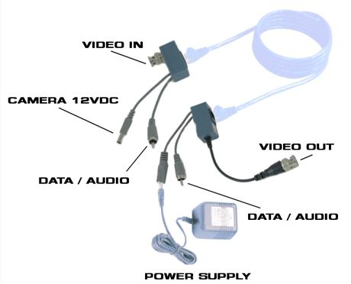

Ref 999700

