Alimentation/voeding
Features:
Constant Voltage Design
Class 2 power unit Withstand Voltage I/P-O/P: 3kVAC
Protection:Short circuit,Overload,Over voltage,Over temperature Safety: EN60950
EMC Emission: EN55022 EN61000-3-2 EN61000-3-3 EMC Immunity: EN61000-4-2,3,4,5,6,8,11 EN55024
IP67 design for indoor or outdoor installations 100% full load burn-in test
3 years warranty

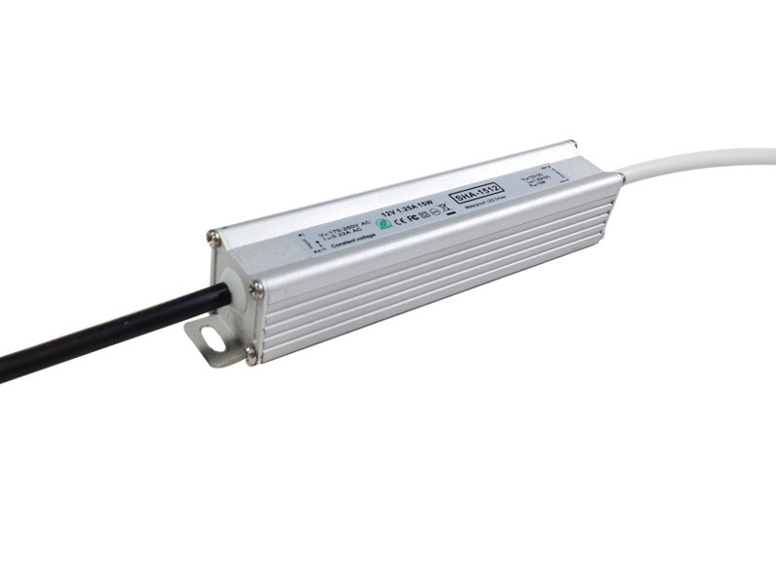Ref : 812015
IP67
12V – 15W

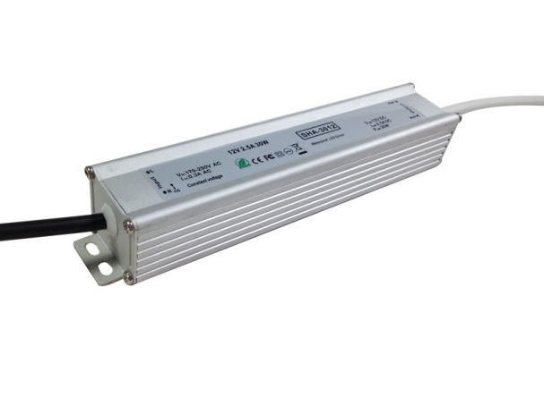
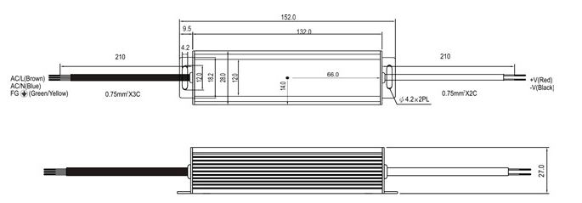
--------------------------------------------------------------------------------------------------------------------------------------
Ref : 812030
IP67
12V-30W

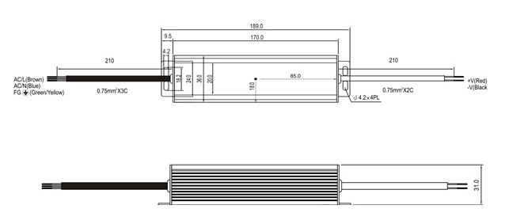--------------------------------------------------------------------------------------------------------------------------------------
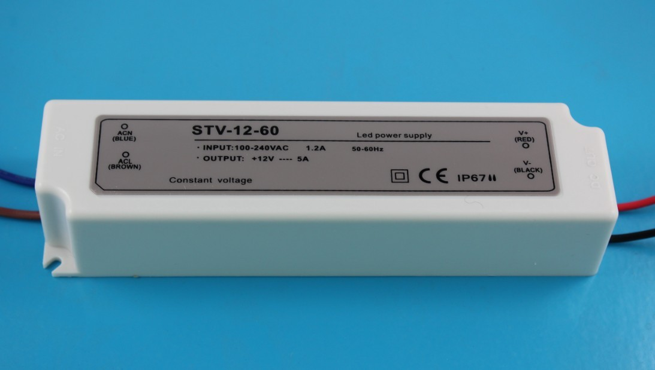Ref : 812060
IP65
12V – 60W

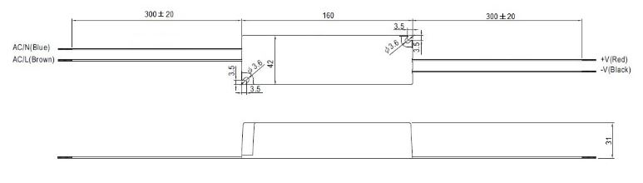
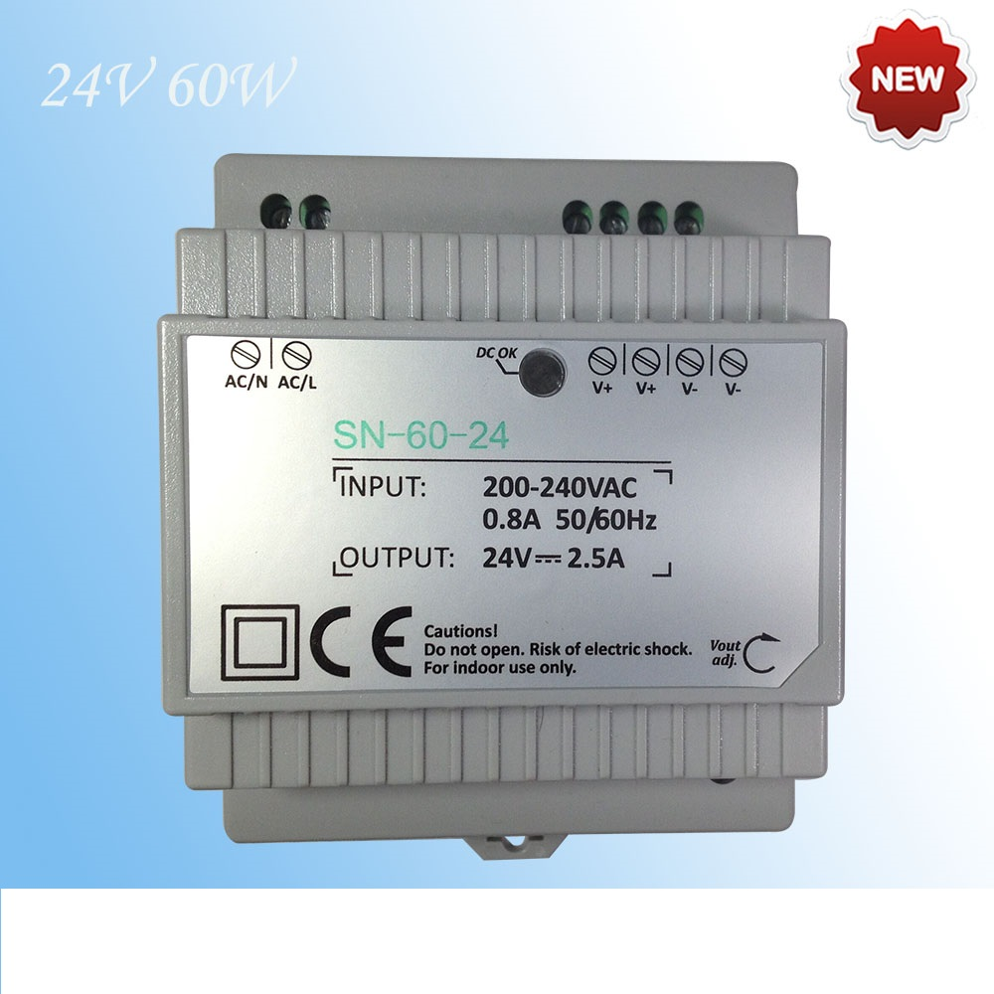--------------------------------------------------------------------------------------------------------------------------------------
Ref : 824601
24V – 60W
Din

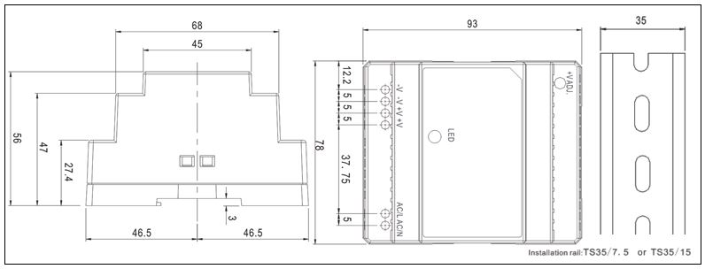---------------------------------------------------------------------------------------------------------------------------
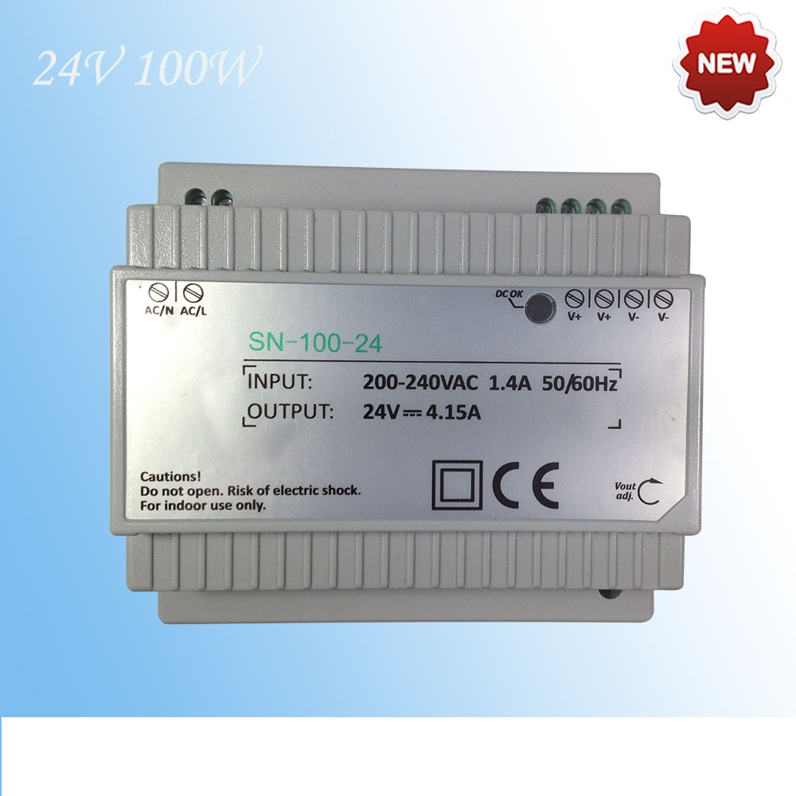
Ref : 824101
24V – 100W
Din

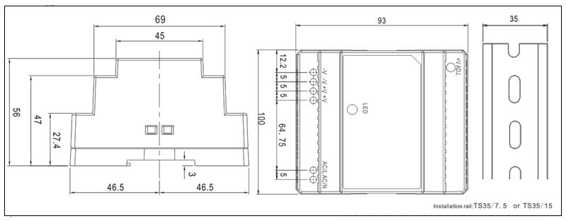

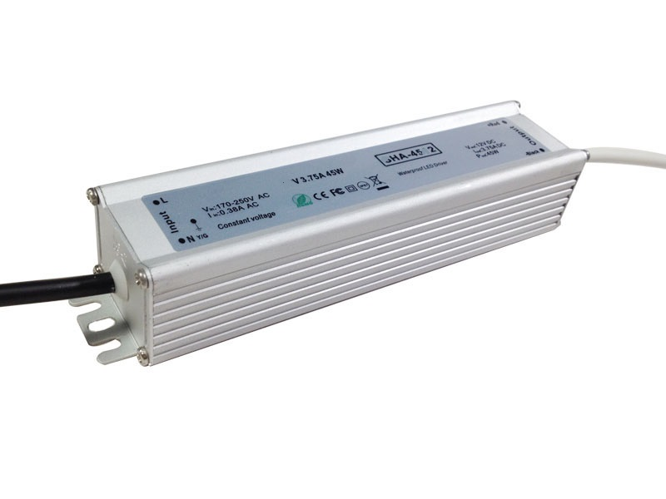Ref : 824045
IP67
24V – 45W

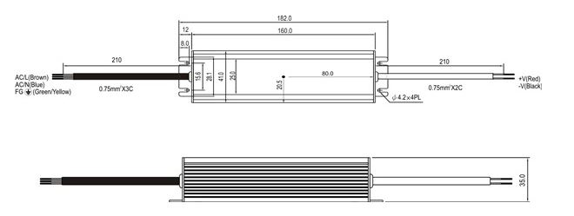
---------------------------------------------------------------------------------------------------------------------------
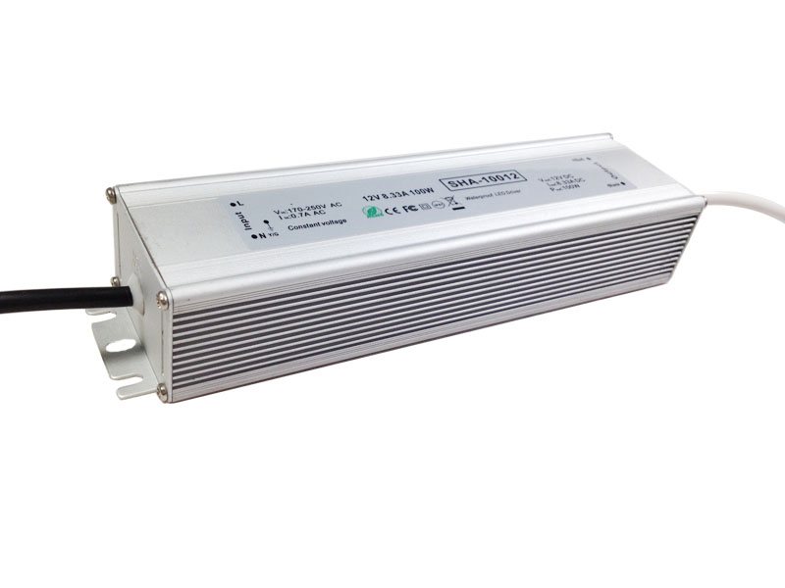Ref : 824100
IP 67
24V – 100W

